THEORY QUESTIONS
PAPER 2
ESSAY
[100 MARKS]
2 hours 10 minutes
Answer all the questions in your answer booklet.
This paper is in two sections: A and B. Answer Question 1 in Section A and any other three questions in Section B.
Credit will be given for clarity of expression and orderly presentation of material.
SECTION A
[40 marks]
Answer all the questions in this section
1.
(a)

Figure 1(a) is an illustration of a natural cycle showing unnamed stages and processes labelled A, B, C and D with processes labelled P, Q, S and T. Study the figure carefully and answer the questions that follow.
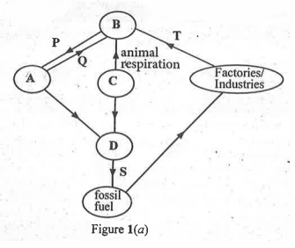
(i)

Name each of the stages labelled A, B, C and D.
(ii)

Name each of the processes labelled P, S and T.
(iii)

State three activities of humans that could disrupt the cycle.
[10 marks]
(b)

Figure 1(b) is an illustration of two types of farming systems practised in Ghana labelled K and L.
System K represents four farmlands labelled A, B, C and D and the arrows indicate movement of the farmer over a period of time as shown.
System L, represents a farmland divided into four plots 1, 2, 3 and 4 and the arrows indicate the movement of the crops cultivated over the period.
Study the figure carefully and answer the questions that follow.
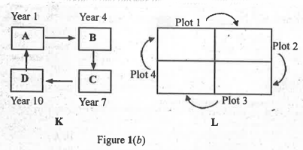
(i)

Name each of the farming systems labelled K and L
(ii)

Give the reason for each of the names given in (i).
(iii)

State two ways in which the farming system K is of importance to the farmer.
(iv)

Give three reasons why the farming system K is not being encouraged in recent times.
(v)

Name one type of crop that could be included in the farmland L to improve the fertility of the soil.
[10 marks]
(c)

Figure 1(c) is an illustration of a mason pulling a slab by means of a rope up an inclined plane. The labels I, II and III represent forces acting on the slab.
Study the figure carefully and answer the questions that follow.
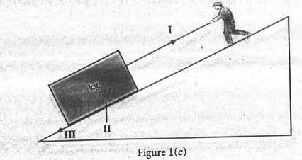
(i)

Give three examples of the use of inclined planes in everyday life.
(ii)

Given that I is 400 N and moves a distance of 10 m whiles II is 100 N and moves a distance of 5 m, calculate the
(α)

work output;
(β)

work input;
(γ)

efficiency.
[10 marks]
(d)

Figure 1(d) is an illustration of experimental set-ups A and B used to demonstrate a scientific principle.
Study the figure carefully and answer the questions that follow.
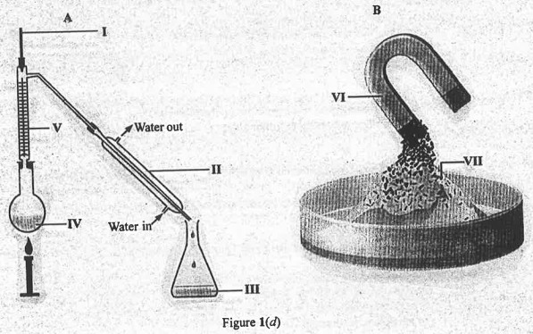
(i)

Name the scientific principle being demonstrated in both A and B.
(ii)

Describe briefly the functions of each of the parts labelled II and VI.
(iii)

Name any two types of materials that could be present in each of the set-ups labelled:
(α)

III;
(β)

VII.
(iv)

Give the reason why the direction of water flow in A must not be reversed.
[10 marks]

SECTION B
[60 marks]
Answer three questions only in this section
2.
(a)

(i)

State three ways of conserving energy in the house.
(ii)

An electrical appliance in the house uses 4000 W of electric power every 12 hours.
Calculate the energy used within this time.
[7 marks]
(b)

(i)

Give two examples of an acid-base indicator.
(ii)

State the colour change of each indicator given in (i) in an orange juice.
[4 marks]
(c)

(i)

State four activities that could be undertaken to ensure a green economy in Ghana.
(ii)

Name two primary green-house gases associated with industrialization.
[6 marks]
(d)

Describe briefly how compost could be prepared for a backyard garden.
[3 marks]

3.
(a)

Name two:
(i)

animal products used in preparing protein-rich feed for poultry;
(ii)

plant produces used in preparing carbohydrate-rich feed for poultry.
[4 marks]
(b)

Describe briefly the water cycle.
[6 marks]
(c)

Consider the following mixtures:
Air, vinegar.
Air is essential to life.
Vinegar is a common household substance.
(i)

Name the two major components of each mixture.
(ii)

Which of the components named in (i) acts as the solvent in each of the mixtures?
[6 marks]
(d)

(i)

State two reasons why there is no life on the planet Jupiter.
(ii)

List two other outer planets without life.
[4 marks]

4.
(a)

(i)

Explain briefly why a kitchen knife is sharpened in order to cut a piece of yam easily.
(ii)

A force of 10 N is exerted on a piece of yam using a knife of cross-sectional area 1 x 10⁻³ m³.
Determine the pressure exerted.
[6 marks]
b)

Outline the procedure used to estimate the pH value of a soil sample.
[6 marks]
(c)

A patient's blood pressure when measured read 150/90 mmHg.
(i)

State the significance of the values.
(ii)

State three remedies that could be recommended to the patient referred to in (c) other than medication.
[5 marks]
(d)

State three characteristics of silage that has made its use desirable in recent times.
[3 marks]

5.
(a)

Explain briefly how each of the following farming systems are practised:
(i)

organic farming;
(ii)

mixed farming;
(iii)

mixed cropping.
[6 marks]
(b)

Classify a mixture of each of the following pairs of substances as either a homogeneous or heterogeneous mixture:
(i)

oil and water;
(ii)

salt and water;
(iii)

ethanol and water.
[3 marks]
(c)

(i)

Give two reasons why energy from the sun is said to be renewable.
(ii)

State three differences between heat and temperature.
[5 marks]
(d)

Explain briefly two effects each of the following factors on the Nitrogen cycle:
(i)

leaching;
(ii)

removal of leguminous plants.
[6 marks]
Show Solution

